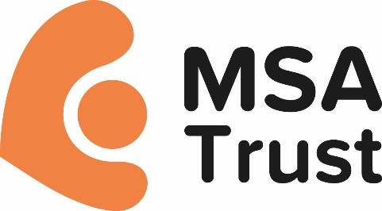

**Multiple System Atrophy Trust Policy and Procedure: Volunteer Expenses**

# Why We Have This Policy

We are very grateful to many volunteers that meet incidental expenses with their own resources. However we do recognise that volunteers are entitled to claim reimbursement of all necessary, and reasonable pre-agreed expenses incurred whilst volunteering with us. We have created this policy to provide a clear and straightforward way of doing so.

# Before Making a Claim

Before making an expenses claim, we ask all volunteers to check that:

* The expenses they are making a claim for were necessary and incurred only as a result of undertaking their volunteer role with us
* The expenses are reasonable and were made using the most cost effective method available, always considering personal safety and wellbeing
* Expenses incurred have been agreed with us in advance
* All expenses were incurred within the last two months.

# Eligible Expenses

* **Public Transport**

We ask that standard class public transport be used when travelling on behalf of the Trust. We ask volunteers to agree travel with us first and book tickets as far in advance as possible in order to make best use of any concessions, special offers or discounts.

This includes bus, coach, train, tram, ferry and where appropriate, air travel. Tickets purchased should be for journeys made on behalf of the Multiple System Atrophy Trust only. If you are using a pre-pay scheme such as Oystercard, please submit a print-out of the individual journeys made, highlighting which journeys are being claimed for. Please be aware that we are unable to reimburse the purchase of any form of season ticket or railcard (such as young persons, senior or disability railcards) as these can be used for other journeys so are classed as a taxable benefit by HMRC.

# Taxis

We would ask that taxis only be used when considered essential, and where public transport is not practical, accessible, safe, or where there is an emergency.

# Driving Private Vehicles

If public transport is impractical or more expensive than the cost of using a private vehicle, we will reimburse the pre-agreed cost of travel at the following mileage rates:

|  |  |
| --- | --- |
| The first 10,000 miles in the tax year Car 45p per mile  Motorcycle 24p per mile | Over 10,000 miles in the tax year Car 25p per mile  Motorcycle 24p per mile |

*The above rates are set by HMRC. Volunteers and staff should be aware that these rates are reviewed annually by HMRC and any changes are at the discretion of the Trust.*

Parking costs, toll and congestion charges can also be claimed for where unavoidable; however, we are unable to reimburse parking fines or speeding tickets.

We do not provide motor insurance for volunteers. Use of a personal vehicle for volunteering purposes is not automatically covered by standard car insurance. Whilst some insurance companies will count volunteering within the ‘domestic, social and pleasure’ category, others require it to be classified under business miles. We recommend that anyone considering using their vehicle in connection with volunteer work should check with their motor insurer. We will ask all volunteers claiming mileage expenses to sign the relevant section on the Volunteer Expenses Claim Form to confirm that they have business class motor insurance in place or have agreed their driving on Trust business with their insurer.

# Lunch

# If you are working over four hours a day volunteering for the Trust in our London office, you are entitled to a £5 lunch allowance each day. Receipts must be kept for all purchases and submitted as detailed below.

# Other Expenses

There may be occasions when volunteers are eligible to make claims for other expenses, such as subsistence, overnight accommodation, administration costs etc. Volunteers are asked to discuss any other expenses with their contact person at the Trust in advance.

# Reimbursement of Expenses

* All volunteers are asked to claim expenses by using the Volunteer Expenses Claim Form
* Forms are available from the Trust office who will also authorise completed claims
* We ask that all claims be made within two months of the expense being incurred
* All volunteer expenses will be reimbursed by direct bank transfer using the details provided on the Volunteer Expenses Claim Form
* Completed claim forms should be received by Trust no later than the 15th of each month for payment by the last working day of the month.

Reviewed: February 2021